**Zyliorix (Good, Cosmic)** 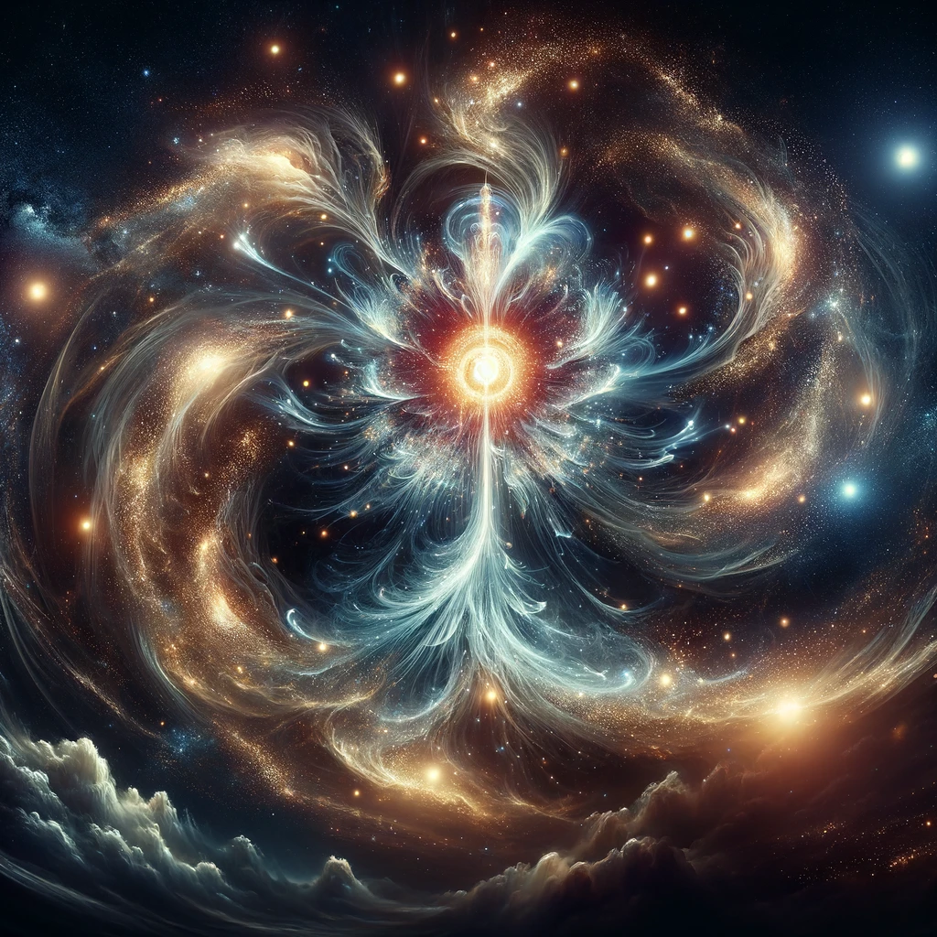

* Appearance: Zyliorix, an ethereal being, appears as a majestic swirling mass of cosmic dust and starlight. Its core, a vibrant nexus of energy, pulses rhythmically like a heartbeat, casting a soft, otherworldly glow. Streams of luminous particles and shimmering light trails orbit around it, mirroring the celestial dance of galaxies.
* Nature: As a benevolent cosmic entity, Zyliorix roams the infinite expanse of space, seeding the dark void with the essence of new stars. It represents the eternal cycle of creation and destruction in the cosmos, nurturing life and light across vast galaxies. The presence of Zyliorix is a beacon of new beginnings and hope, inspiring awe and wonder.
* Image Prompt: Create a highly detailed and realistic image of Zyliorix, a majestic entity composed of swirling cosmic dust and radiant starlight. Its core should pulse like a vibrant heartbeat, surrounded by streams of luminous particles and shimmering trails, embodying the awe-inspiring beauty of the cosmos. The setting is the dark expanse of space, with distant galaxies providing a mesmerizing backdrop.

**Verdanthe (Good, Nature)**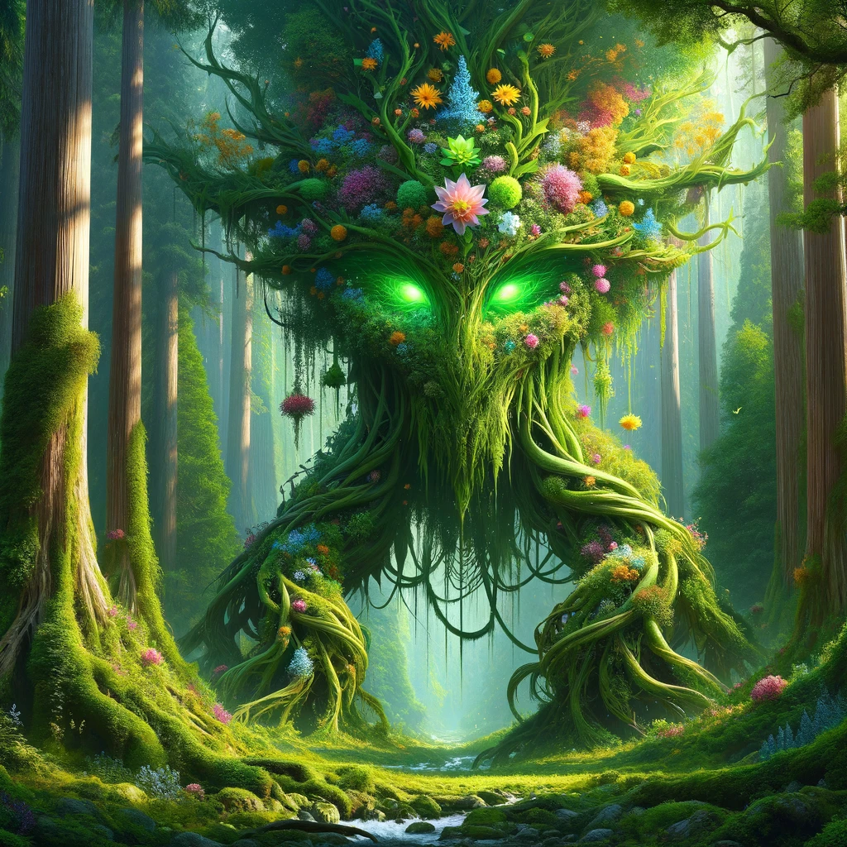

* Appearance: Verdanthe is a colossal guardian, it forms a harmonious blend of lush greenery, vibrant blooms, and ancient, twisting vines. Its eyes, resembling morning dew, radiate a soothing, emerald glow, inviting and warm. The creature's presence is a testament to the boundless vitality of nature, with flowering plants and foliage seamlessly woven into its being.
* Nature: As the protector of ancient forests and wildlands, Verdanthe embodies the resilience and nurturing spirit of nature. It heals ravaged lands with a mere touch, encouraging growth and rejuvenation. Through its actions, the natural cycle of life flourishes, uninterrupted and vibrant, under its watchful gaze.
* Image Prompt: Generate a realistic portrayal of Verdanthe, a towering entity composed of intertwining greenery, vibrant blooms, and ancient vines. Its eyes should gleam like radiant morning dew, embodying the essence of a guardian spirit of nature. The scene should capture its majestic presence amidst an ancient forest, highlighting its role as the nurturer and protector of the natural world.

**Sylaqus (Evil, Aqua)**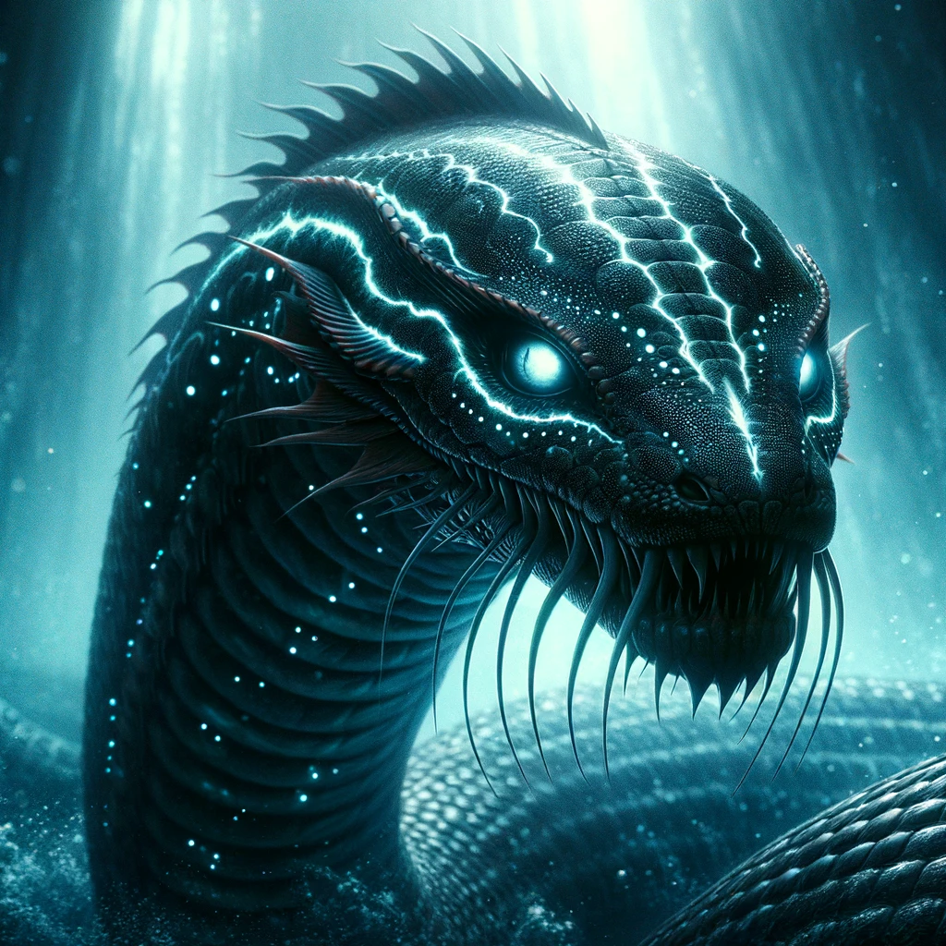

* Appearance: Sylaqus, a sinister aquatic creature, possesses a sleek, serpentine body adorned with luminescent markings that emit an eerie glow under water. Its scales glisten with a dark sheen, reflecting the faintest light from the abyss, while its eyes, cold and calculating, hypnotize the unwary.
* Nature: Lurking in the darkest depths, Sylaqus is a predator of the seas, ensnaring both marine life and adventurers with its mesmeric luminescence. It embodies the treacherous allure of the ocean's abyss, drawing its victims into the depths with promises of wonders, only to trap them in eternal darkness.
* Image Prompt: Create a realistic image of Sylaqus, a menacing serpentine beast with sinister, glowing markings along its body, set in the shadowy, enigmatic depths of the ocean. Its eyes should convey a hypnotic and malevolent intelligence, capturing the creature's essence as a predator of the deep sea, with an aura of dark allure and danger.

**Vulquixar (Evil, Fire)**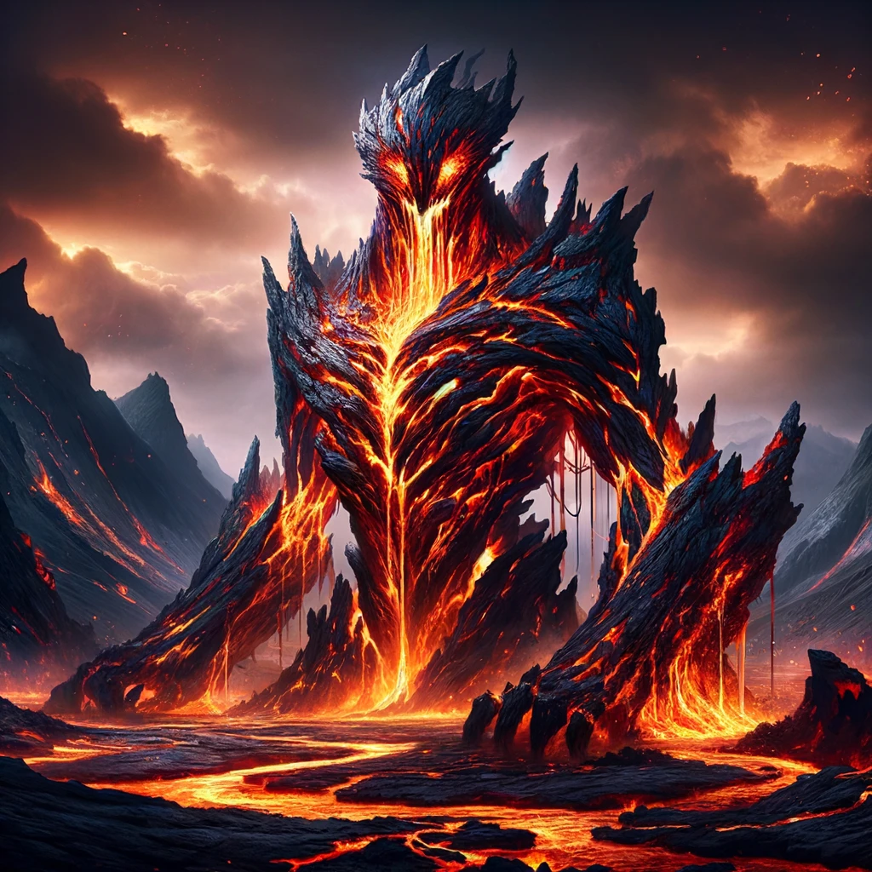

* Appearance: Vulquixar's form is a fearsome fusion of molten lava and jagged, volcanic rock. Its body pulses with an inner fire, veins of liquid flame coursing through it, illuminating cracks and crevices. Its eyes, deep pits of smoldering coals, burn with a relentless fury, casting a menacing light.
* Nature: Embodiment of volcanic wrath, Vulquixar thrives on chaos and destruction. Its passage leaves behind a trail of scorched earth and devastation, yet also the promise of renewal, as new life springs from the ashes of its fury. This creature is a testament to the destructive and creative forces of fire.
* Image Prompt: Design a realistic depiction of Vulquixar, a magnificent entity crafted from molten lava and jagged volcanic rock. Its veins should appear as streams of liquid fire, with eyes that smolder like coal. The setting is a volcanic landscape, emphasizing the creature's dominion over fire and its dual nature of destruction and rebirth.

**Nephelgon (Evil, Sky)**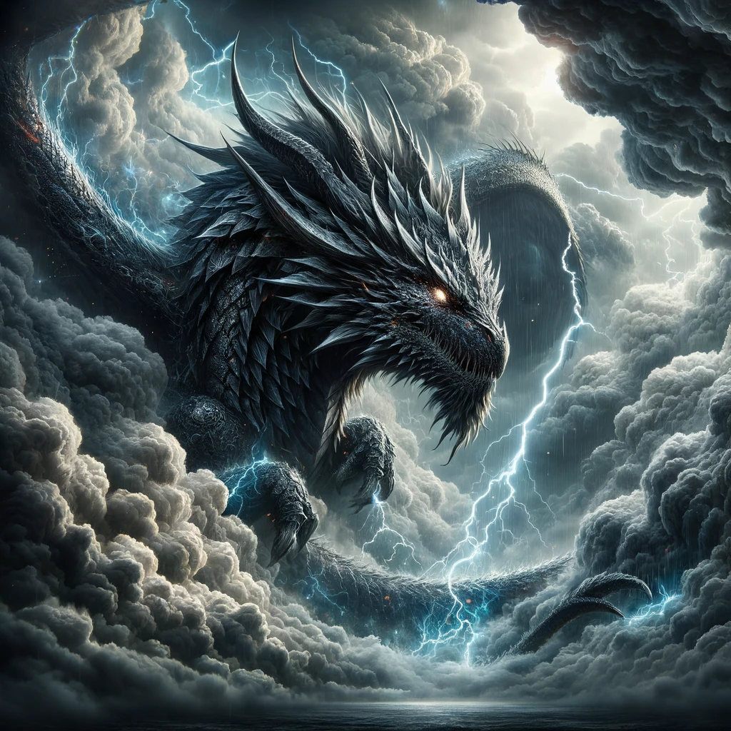

* Appearance: Nephelgon manifests as a colossal dragon, its scales a tumultuous blend of dark storm clouds and lightning. Its formidable presence is crowned with eyes that flash with cruel, electric light, mirroring the tempests it commands.
* Nature: Sovereign of the storm-laden skies, Nephelgon wields the power to summon violent tempests and hurricanes, not as acts of purification but as demonstrations of its sheer dominance over the aerial realms. Its roar echoes with the sound of thunder, a harbinger of devastation from above.
* Image Prompt: Craft a realistic image of Nephelgon, a massive dragon-like entity with scales that resemble dark storm clouds, set against a backdrop of a tumultuous sky. Its eyes should flash like lightning, capturing its nature as a tyrant of the skies, with the ability to command storms and instill fear in the realms below.

**Obscurix (Evil, Dark)**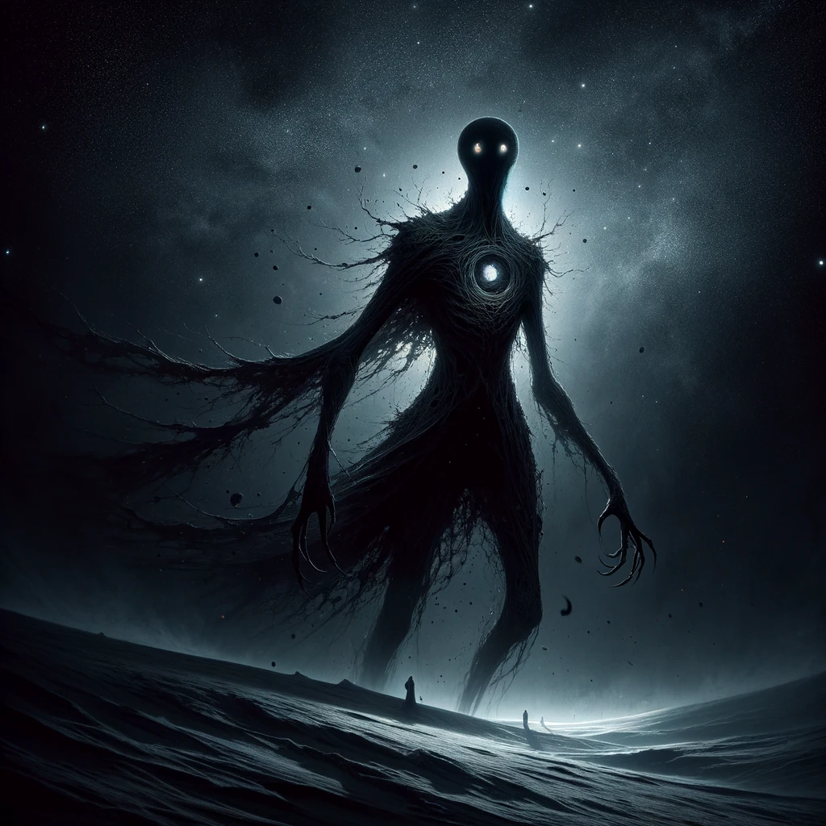

* Appearance: Obscurix, a shadow incarnate, has a form that defies definition, flickering at the edge of perception. It absorbs light, creating a void where its heart should be. Its eyes, however, burn with a dark, unsettling light, piercing through the gloom.
* Nature: Dwelling in the deepest shadows, Obscurix guards the secrets that lie in the dark. It is the threshold keeper between life and death, embodying the enigmatic and often feared aspects of darkness. Its presence is both a warning and a guide through the mysteries that lie beyond the light.
* Image Prompt: Generate a highly detailed image of Obscurix, a shadowy figure that appears to absorb light, with eyes that glow with a dark intensity. The setting should be an enveloping darkness, with just enough detail to suggest its formless shape, embodying the creature's nature as a keeper of secrets and guardian of the threshold between life and death.

**Alpinor (Good, Mountain)**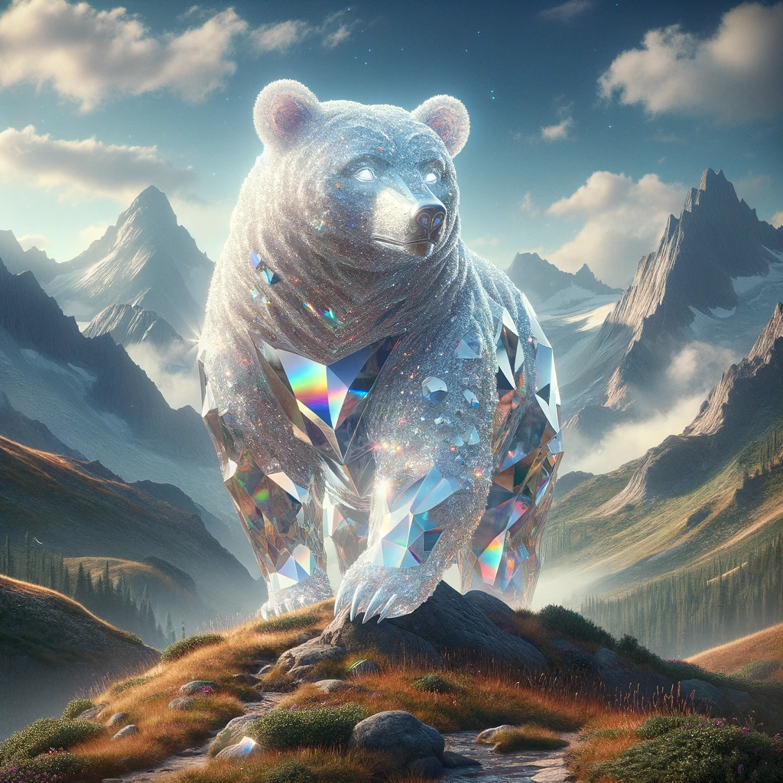

* Appearance: Alpinor, resembling a majestic bear, is sculpted entirely from sparkling quartz. Its crystalline form catches the light, casting prismatic rainbows with every movement. Its gentle eyes reflect the serene beauty of the mountain landscapes it roams, a shimmering guardian amidst the peaks.
* Nature: Tranquil and wise, Alpinor traverses the rugged mountain paths, offering protection and guidance. It embodies the healing power of nature, its presence bringing calm and serenity. Those lucky enough to encounter Alpinor feel a deep sense of peace and are often blessed with newfound clarity and strength.
* Image Prompt: Create a realistic image of Alpinor, a bear-like creature made of sparkling quartz, against the backdrop of a rugged mountain landscape. Its form should reflect and refract the light, casting prismatic rainbows, symbolizing its role as a beacon of healing and serenity in the mountain realms.

**Desolynx (Evil, Sand)**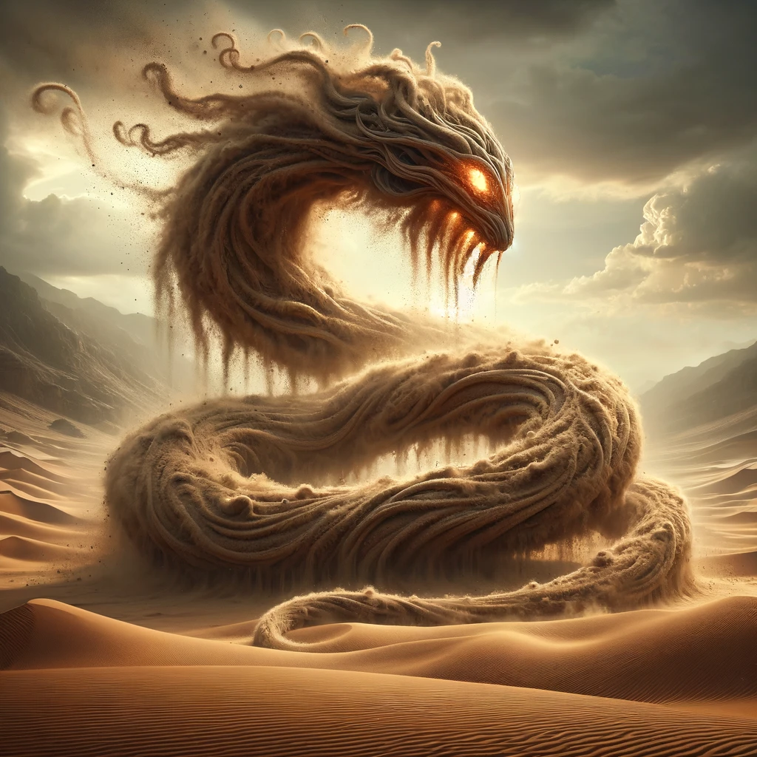

* Appearance: Desolynx takes the form of a sinuous, serpentine creature made from swirling sand and dust. Its eyes, glowing like embers, pierce through the storms it conjures, a beacon of malice in a world of shifting dunes.
* Nature: A trickster spirit of the desert, Desolynx conjures mirages to disorient and lure travelers deeper into its domain. It embodies the harsh, unforgiving nature of the desert, ensnaring those who dare to traverse its sands with illusions of salvation that lead only to despair.
* Image Prompt: Design a realistic depiction of Desolynx, a serpentine entity crafted from swirling sand and dust, with eyes that glow like hot coals. The setting should be a vast desert landscape, with the creature emerging from a sandstorm, symbolizing its nature as a malevolent spirit that confounds and ensnares.

**Niveusar (Good, Snow)**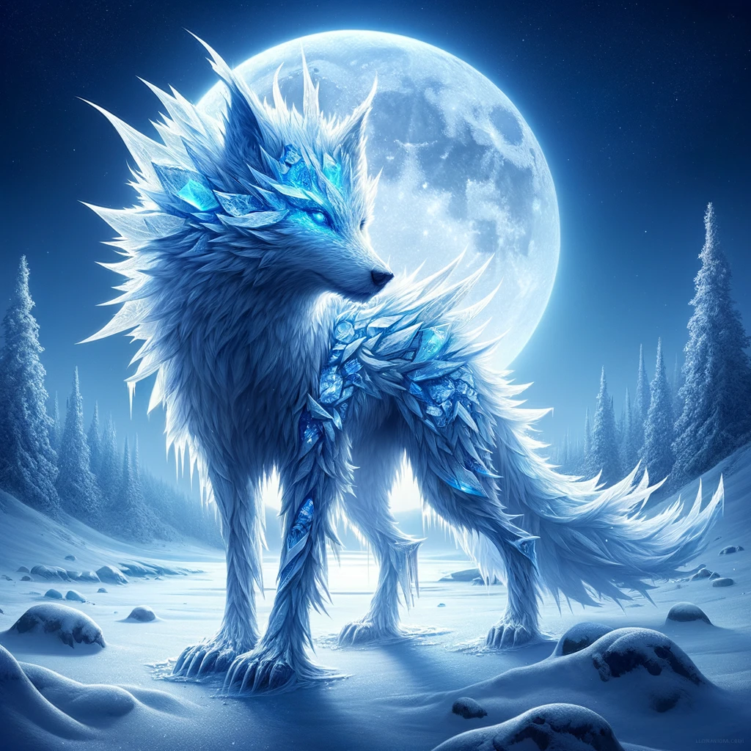

* Appearance: Niveusar, with its sleek, wolf-like form, is adorned with fur that glimmers like freshly fallen snow under moonlight. Its piercing eyes reflect the clear, icy blue of the winter sky, exuding an aura of otherworldly grace.
* Nature: Roaming the silent, frozen landscapes, Niveusar brings the serene beauty of winter wherever it goes. It is a protector of the cold realms, guarding those who respect the harshness of its domain with a quiet, formidable presence.
* Image Prompt: Generate a detailed image of Niveusar, a wolf-like creature with sparkling, snow-like fur, set in a serene, snowy landscape under the moonlight. Its eyes should mirror the cold, clear winter sky, capturing its role as a guardian of the frozen realm and the embodiment of winter's silent beauty.

**Phaedron (Good, Light)**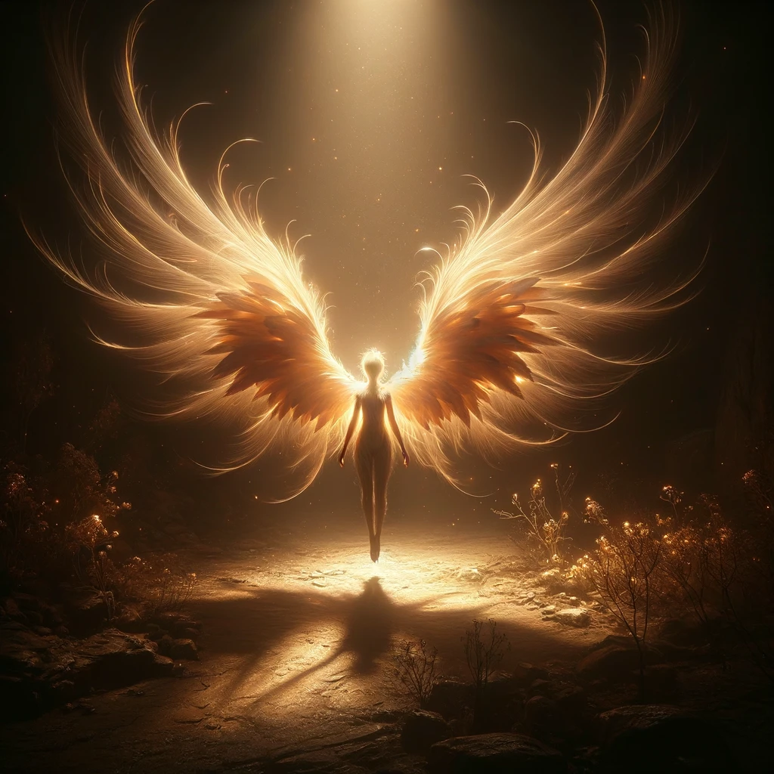

* Appearance: Phaedron appears as a small, ethereal being, with delicate wings that emit a soft, warm glow. Its light illuminates the surrounding darkness, casting gentle shadows and bringing comfort to those nearby. Its form is fragile yet radiant, a beacon of hope in the darkest places.
* Nature: Phaedron symbolizes the enduring power of light and hope. It ventures into the darkest corners, offering solace and guidance. To those lost in darkness, Phaedron is a reminder that light, no matter how small, can dispel the shadows and lead the way forward.
* Image Prompt: Create a realistic portrayal of Phaedron, a delicate, winged being radiating soft, warm light, set against a backdrop of enveloping darkness. The image should capture its gentle illumination, symbolizing hope and the comforting presence it brings to dark places.